

**INTERNATIONAL SCHOOL**

**COURSE PROJECT 1**

**CMU-CS 246**

**USER INTERFACE DESIGN DOCUMENT**

Version: 1.1

**SIMPLE CALCULATOR SYSTEM - SC**

**Mentor: Nguyen Dang Quang Huy**

***Team Member*:**

Thanh, Tran Nguyen Duy

Thien, Nguyen Ngoc

Khang, Tran Quoc

Dinh, Dang Quoc

Huy,Van Viet Bao

**Approved by Huy Nguyen Dang Quang, Msc**

**UserInterface Review Panel Representative:**

Name Signature Date

**Course Project 1- Mentor:**

Name Signature Date

Da Nang, 01/2024

**PROJECT INFORMATION**

|  |  |
| --- | --- |
| **Project Acronym** | SC |
| **Project Title** | Simple Calculator System | | | |
| **Start Date** | 25 – Jan –2024 | **End Date** | 18– Feb –2024 | |
| **Lead Institution** | International School, Duy Tan University | | | |
| **Team Member** | **Name** | **Email** | | **Phone** |
| 28219448044 | Thien Nguyen Ngoc | anh.ty.dn111@gmail.com | | 0707155003 |
| 28214634771 | Thanh Tran Nguyen Duy | [doyouwanttobe23@gmail.com](mailto:doyouwanttobe23@gmail.com) | | 0395114654 |
| 28211102614 | Dinh Dang Quoc | dinhfury2004@gmail.com | | 0867530103 |
| 28211100259 | Khang Tran Quoc | khangtran12pro@gmail.com | | 0338917278 |
| 28210200735 | Huy Van Viet Bao | [Hdegamer4@gmail.com](mailto:Hdegamer4@gmail.com) | | 0339707246 |

**PROJECT PLAN DOCUMENT**

|  |  |  |  |
| --- | --- | --- | --- |
| **Document Title** | USER INTERFACE DESIGN DOCUMENT | | |
| **Author(s)** | Team 4 | | |
| **Date** | Feb 1st, 2024 | **File name:** | User-Interface-Design Document_Team_4_v1.1.docx |
| **URL** | https://drive.google.com/drive/folders/1XsjP3887YuNl4E8YRmeDQmnNr0JNnVw_?fbclid=IwAR1npPU37wub7awmm4oLGPfSYMRZIwNWM7KVq6PoMy8BXA4z39mlktqWrrY | | |
| **Access** | Huy Nguyen Dang Quang and Team 4 | | |

**SIGNATURE**

**Document Approvals:** The following signatures are required for approval of this document.

|  |  |  |  |  |
| --- | --- | --- | --- | --- |
| **Mentor** | Huy, Nguyen Dang Quang | | **Signature:** |  |
| **Date:** |  |
| **Scrum master** | Thanh, Tran Nguyen Duy | | **Signature:** |  |
| **Date:** |  |
| **Team member(s)** | Thien, Nguyen Ngoc | | **Signature:** |  |
| **Date:** |  |
| Khang, Tran Quoc | | **Signature:** |  |
| **Date:** |  |
| Dinh, Dang Quoc | | **Signature:** |  |
| **Date:** |  |
| Huy,Van Viet Bao | **Signature:** | |  |
| **Date:** | |  |

**DOCUMENT HISTORY**

|  |  |  |  |
| --- | --- | --- | --- |
| **Version** | **Person** | **Date** | **Description** |
| 1.0 | Huy,Van Viet Bao | Jan 25th, 2024 | Draft |
| 1.1 | Huy,Van Viet Bao | Feb 17th, 2024 | Update |

TABLE OF CONTENTS

I. DESCRIBE USER INTERFACE 5

# DESCRIBE USER INTERFACE

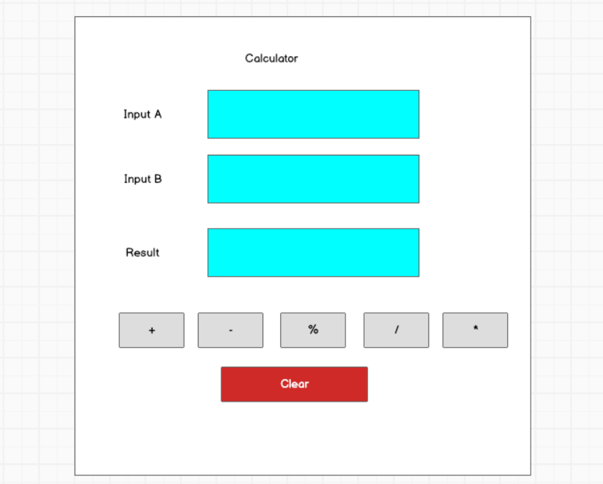

|  |  |  |  |
| --- | --- | --- | --- |
| **ID** | **Condition** | **Control Type** | **Target** |
| 1 | Press | Input text | Enter the first number |
| 2 | Press | Input text | Enter the second number |
| 3 | Press | Button | Click to perform the addition operation and display the result |
| 4 | Press | Button | Click to perform the subtraction operation and display the result |
| 5 | Press | Button | Click to perform the modulo division operation and display the result |
| 6 | Press | Button | Click to perform the division operation and display the result |
| 7 | Press | Button | Click to perform the multiplication operation and display the result |
| 8 | Press | Button | Click to reset the input fields to their initial state |